Consumer-mediated nutrient cycling across latitudes

Em G Lim¹ and Isabelle M Côté¹

Affiliations
¹Biological Sciences, Simon Fraser University, Vancouver, British Columbia, CAN

Corresponding author: Em Lim (ORCiD: 0000-0002-3586-2108), em.g.lim13@gmail.com

Abstract
Consumer-mediated nutrient cycling (CNC) refers to metabolic waste products of animals that can fertilize and bolster primary productivity. Despite the widespread assumption that CNC is less important in nutrient-rich temperate waters, empirical tests for global-scale patterns of CNC effects on primary producers are lacking. Here, we conducted a meta-analysis of published literature to assess the effects of animal-provisioned nutrients on primary productivity in marine ecosystems. We identified 41 suitable studies, from which we calculated effect sizes as response ratios of productivity of provisioned vs unprovisioned systems. We quantified and compared the effect sizes reflecting the growth benefit of CNC to primary producers between temperate and tropical regions, considering latitude, temperature, and external nutrients. Our results show no difference in the effect of CNC on primary productivity between temperate vs tropical regions, contradicting the prevailing ecological paradigm. This suggests that the effects of CNC on primary producers may be driven by smaller-scale processes that are not generalizable across broad regions.

Introduction
Although anthropogenic eutrophication has had some catastrophic effects across terrestrial and aquatic ecosystems (Smith et al., 1999), natural nutrient enrichment remains an important process in supporting primary productivity and thus ecosystem structure. Provisioning of nitrogen, phosphorus, and other limiting elements can dramatically alter communities beyond simply increasing primary productivity across ecosystems (Gough et al., 2016). However, nutrient provisioning is important only relative to the nutrient demands of the primary producer. For example, tropical tree species show variable responses to nitrogen enrichment, but consistently positive responses to phosphorus (Fortier and Wright, 2021). The impact of provisioning also depends on the availability of nutrients in the system; phosphorus enrichment famously causes algal blooms in lakes, while nitrogen fails to produce a similar effect when added in isolation (Schindler, 1974). In rainforests, seedlings adapted to nutrient-poor soil are limited in their response to nutrient addition, but seedlings from nutrient-rich soil respond strongly to fertilization (Zalamea et al., 2016). Finally, even the form and relative amounts of the supplied nutrients are important. In general, the addition of nitrogen and phosphorus in combination produces the largest increase in primary productivity across systems (Elser et al., 2007), although non-additive effects are common (Allgeier et al., 2011).

Although consumers are often assumed to mediate primary productivity through “top-down” effects, e.g. herbivory, they can also mediate “bottom-up” processes through metabolic nutrient release (Allgeier et al., 2017). Nutrient provisioning by consumers via excretion or egestion, henceforth termed consumer-mediated nutrient cycling (CNC), has been shown to substantially affect primary productivity and community functioning in aquatic (Atkinson et al., 2017; Vanni, 2002), terrestrial (McNaughton et al., 1988; Sitters et al., 2017), tropical (Meyer et al., 1983; Peterson and Heck, 2001) and some temperate (Bracken et al., 2007; Pfister et al., 2014) marine ecosystems. CNC refers both to the storage and cycling of nutrients through animal tissues, processes which are governed by stoichiometry (Elser and Urabe, 1999) and metabolic rates (REF). Scaling up from the individual to the population or community level can be challenging, but in general the amount of CND depends on the biomass and diversity of the total community of animals in a system (Allgeier et al., 2017).

In marine ecosystems nitrogen is the dominant limiting nutrient for primary producers (Ryther and Dunstan, 1971), which contrasts with terrestrial and freshwater ecosystems, which are co-limited by phosphorus and nitrogen (Elser et al., 2007). Specifically, the growth of many species of algae (Jackson, 1977), seagrasses (Hillman et al., 1989), and phytoplankton (Moore et al., 2013) is limited by the availability of inorganic nitrogen, both exogenous and endogenous to the system. Exogenous nitrogen sources can profoundly affect marine primary productivity (Probyn and McQuaid, 1985; Smith et al., 1999). In particular, coastal upwelling – the delivery to the surface of deep, nutrient-rich waters via offshore winds – can be an important source of nitrogen that drives the productivity of temperate marine ecosystems (McPhee-Shaw et al., 2007). Two additional external terrestrial sources – natural weathering of rocks and agricultural run-off – also supply nutrients to nearshore marine ecosystems (CITE). However, all three sources supply nitrogen in the form of nitrates (NO₃⁻), which requires metabolic conversion by plants and algae before use (Probyn and McQuaid, 1985; Smith et al., 1999). In contrast, many marine animals, such as fishes and invertebrates, contribute nitrogen (e.g. via excretion) in the form of ammonium (NH₄⁺), which is available for direct uptake and is thus preferred (Phillips and Hurd, 2004). Therefore, excretion by marine animals represents an important endogenous source of nutrients in marine ecosystems (Allgeier et al., 2017). Furthermore, marine animals represent the largest pool of standing biomass, so their processes dictate the rate of internal nutrient cycling (ref?). Consequently, the total available nitrogen content in marine systems can determine trophic energy transfer, and therefore total ecosystem biomass, mainly through bottom-up processes.

There is a widespread, although untested, assumption that the effect of CND should be largest in ecosystems with low external nutrient input, such as coral reefs (REF). However, several lines of evidence contradict this assumption. CND has been shown to significantly bolster primary productivity in some areas with high external nutrient input, such as those frequently found in temperate latitudes. For example, Pfister et al. (2014) found that animal-derived ammonium contributed more to the overall nitrogen budget of a temperate rocky reef ecosystem than nitrates from upwelling. In temperate tidepools that are isolated from the ocean for extended periods of time, CND can prevent nutrient depletion and support continuous productivity (Bracken, 2004). Furthermore, in high-nutrient upwelling systems, the delivery of nitrates may be mismatched with the timing of summer productivity (Jackson, 1977; McPhee-Shaw et al., 2007), necessitating alternative nutrient sources in the summer (Brzezinksi et al., 2013). Finally, even when nitrates are abundant, ammonium is more readily taken up by primary producers (Phillips and Hurd, 2004). Consumer-mediated nutrients might therefore be an overlooked source of nitrogen that drives bottom-up processes in temperate systems. Empirical tests for global-scale patterns of CNC effects on primary producers are currently lacking.

In this study, we assessed the effects of animal-provisioned nutrients on primary productivity in different marine ecosystems, and specifically tested whether these effects are more marked in nutrient-poor environments. By conducting a systematic review and meta-analysis of published literature, we sought to quantify and compare the extent to which animal-mediated nutrient provisioning bolsters primary productivity in temperate and tropical regions. Our results strengthen our understanding of consumers in mediating not just top-down processes, but also bottom-up processes on a global scale. Furthermore, we hope this work will highlight the often-overlooked role of animals in marine nutrient dynamics.

Methods
Literature search and article screening
We conducted a systematic review and meta-analysis of existing literature to investigate the effect of animal-provisioned nutrients on marine primary producers. Our literature search targeted five key elements for articles to be considered: (1) marine habitat, (2) nutrients, (3) excretion or egestion (4) primary producers, and (5) a measured response. For each element we generated search terms of analogous and synonymous words (see Appendix S1 for full search string). We conducted two consecutive searches, first from 1900 - August 13, 2020, then from August 14, 2020 – January 3, 2022, using the same search strings and limits. The last day of each interval was the day the search was performed. We searched the Web of Science Core Collection (Web of Science) and Aquatic Sciences and Fisheries Abstracts (ProQuest) databases and added two papers from our personal files. In Web of Science, our search yielded 1,257 publications. We refined this list by only including articles and proceedings papers to filter out unreviewed articles, which narrowed the results to 1,164 publications. We then removed publications that were not included in the following Web of Science categories: Marine Freshwater Biology, Environmental Engineering, Ecology, Oceanography, Zoology, Environmental Studies, Limnology, Multidisciplinary Sciences, Biology, Plant Sciences, Fisheries, or Biodiversity Conservation, to remove studies outside of our field, which were generally not relevant, resulting in 1,006 publications. We supplemented this list by conducting a search in the database of Aquatic Sciences and Fisheries Abstracts using the same search string. This second search resulted in 1,428 publications, which narrowed to 1,169 publications once we included only published literature. We excluded the subjects: freshwater, bacteria, aquaculture, lakes, rivers, cyanobacteria, biogeochemistry, and nitrogen fixation to further narrow the results to 784 publications. We merged these two searches and removed duplicates (using revtools::find_duplicates() in R), resulting in 1,429 publications (Fig. S1).

Each record had to meet the following criteria to be included: 1) the study was conducted in the marine environment, 2) animals were the primary contributors of manipulated or observed nutrient levels, 3) the response of primary producers to this nutrient provisioning was measured quantitively, and 4) the study reported all necessary information required to calculate an effect size of animal-provisioned nutrients on primary productivity. We first scanned all titles and abstracts of publications to determine if the articles met our criteria. Next, we combined the screening of the full texts with data extraction. If the publication met all criteria we extracted meta-data and calculated effect sizes from these publications.

Data extraction
Responses of primary producers to changes in nutrient levels were reported as static measurements pertaining to individuals (i.e., length, tissue protein, area, dry weight, and width) or populations (i.e., percent cover, density, biomass, chlorophyll a, abundance) or as rates (e.g., growth, photosynthesis). We extracted the mean, standard deviation, and sample size for both the unprovisioned control and the provisioned treatment to calculate effect sizes as log-transformed response ratios (see below). When studies included multiple treatment levels, we only compared control and maximum treatment levels. For time-series data we considered growth achieved between the first and last measurements. When instantaneous measurements (e.g., oxygen production) were made at multiple time points we included all time points. When data were only available in graph form, we used the program WebPlotDigitizer (https://automeris.io/WebPlotDigitizer/) to extract the means and standard deviations. When standard errors or confidence intervals were provided, we calculated standard deviations from these values. In some cases, we were unable to extract the mean and standard deviation from the publication and used the provided raw data to compute these values ourselves.

We also extracted information on the study location (latitude, longitude, water temperature, background nutrient availability), the experimental design, animal species or groups that provided the nutrients, the primary producer species or groups measured and the types of responses measured, and when the study occurred. We used the latitude and longitude provided by the authors to identify the study location and took the absolute latitude to reflect the distance of each study site from the equator. When coordinates were not provided we extrapolated them from named study locations, and when multiple study coordinates were provided, we used the latitude and longitude of the study site nearest to the centre of the rest. We estimated mean water temperature during the experiments from data reported in the publications, and extrapolated temperature from published values at the same study site when the data were not presented in the original text (n = 20 cases, TABLE S1). We classified background nutrient levels as the total concentration? of nitrogen present in the ambient or control treatment, which could include any combination of nitrate, nitrite and ammonium measured in uM. When these data were not reported (n = 19 cases), we found published values of background nutrient levels recorded at or near the same location and (time/season) (TABLE S2). We also recorded the author’s characterization of the nutrient availability at their study site and ensured the proxy sites chosen matched these descriptions. We scored each experiment’s experimental design on a scale of 1-5; (1) Field: natural experiment, (2) Field: primary producer stocked, (3) Field: provisioning animal stocked, (4) Field: both primary producer and animals stocked, and (5) Mesocosm: lab experiment. Primary producers were grouped into either (1) macroalgae, (2) corals, (3) phytoplankton, or (4) vascular plants. Animals were grouped into (1) vertebrates, (2) mobile invertebrates, or (3) sessile invertebrates.

Data analysis
We examined latitude, temperature, background nutrient concentration, experimental design, and primary producer taxa as potential moderators of the effect of animal-mediated nutrient provisioning on primary producers. We considered grouping primary producers into finer taxonomic levels (e.g., splitting macroalgae into fleshy and crustose algae, or vascular plants into seagrass and mangroves) but preliminary models with these finer groupings did not improve model fit, and we did not detect significant differences among finer groups within their broader categories. We also investigated the effect of consumer taxon or activity level but there were no subgroup differences and inclusion of these factors did not improve the model. We collected data quantifying the level (i.e., nitrogen concentration) of provisioning by animals to primary producers, but this information was unavailable for most studies and inclusion did not improve model fit, so we did not consider this factor in final models.
We calculated effect sizes as log-transformed response ratios using the R function metafor::escalc, which computes effect size as the log of the treatment mean divided by the control mean. Effect sizes cannot be calculated for mean values less than or equal to zero (n = 9 cases), so these were excluded. We standardized the continuous moderators (absolute latitude, temperature, and background nutrients) in the models to make the parameter estimates comparable. Using a correlation matrix (metaphor::vif), we determined that absolute latitude, temperature, and background nutrients were correlated, with VIF values of 6.04, 4.80, and 3.73 respectively. We were therefore unable to include all three moderators in the same model.

We constructed three three-level mixed-effects models (metafor::rma.mv) including in each only one of the correlated moderators (absolute latitude, temperature, or background nutrients), both categorical moderators (experimental design and primary producer group) and a random effect of individual effect size nested within publication (random = ~ 1 | paper /individual_effect_size). As some studies contributed multiple effect sizes, this nested structure accounted for non-independence among effect sizes (Viechtbauer, 2010). We compared the three models to each other and against a null model (i.e., intercept only) using Akaike’s Information Criterion (AIC). We considered delta AIC values < 2 as lending substantial support for the model, and 2 < Δ𝑖 < 7 as having some support (Burnham et al., 2011). We used the restricted maximum likelihood estimator to estimate residual heterogeneity and used Cochran’s Q-test to test the significance of all models. We set test = “t” to use a t-distribution similar to the Knapp-Hartung method.

Testing for biases and non-independence
Meta-analyses can be vulnerable to publication bias, i.e. the higher likelihood of submitting or publishing significant than non-significant results, so we calculated Rosenthal’s failsafe number (i.e., the number of non-significant studies we would have to include to overturn our significant results); the high failsafe-N (50,340) relative to our sample size (give N here) suggests that our results are robust to publication bias. We also created funnel plots and visually inspected them for evidence of small-study bias. The pattern was unusual with many studies with high precision but variable effect sizes and few studies with low precision and near-average effect sizes (Fig. S2). As the pattern was relatively symmetric about the mean (Fig. S2), we interpret it cautiously as reflecting limited publication bias but high heterogeneity. Finally, as some papers contributed multiple observations, we also examined whether papers that contributed 10% or more of the total number of observations (n = 3 papers) had a substantial effect on the results. We reran each model repeatedly, removing one of these potentially influential studies at a time, and found no major differences in effect sizes or p-values. We therefore retained all three studies in the final analysis.
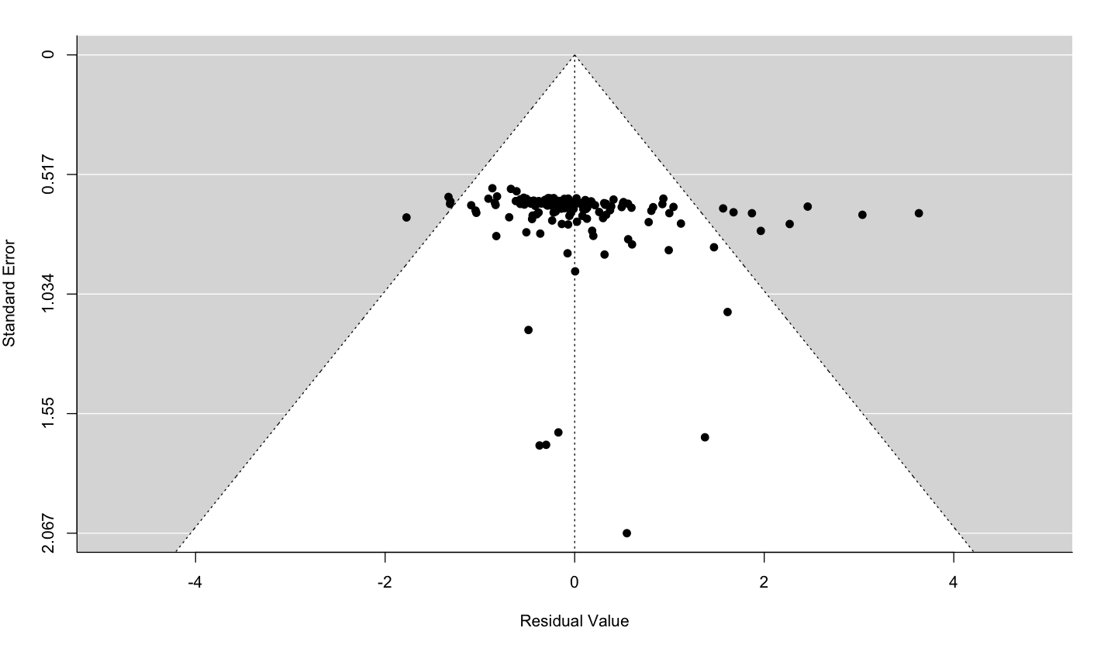
Fig. S2. Funnel plot for the model including background nutrients. What is residual value here? Effect size?? What’s your interpretation of this funnel plot?

Results
Description of dataset
Our systematic literature review narrowed after screening from 1,429 to 37 studies, which contributed 180 individual effect sizes (Fig. S1). The studies spanned a wide range of latitudes, but there was a bias towards studies conducted in North America (Fig. 1A). The majority of effect sizes were drawn from symbiotic cnidarians as the primary producer (n = 55), which represented corals, endosymbionts, and a single anemone. Phytoplankton (n = 53) included both diatoms and dinoflagellates, while vascular plants (n = 45) were primarily seagrasses, in addition to one cordgrass and one mangrove species. Algae (n = 27) were represented by green, red, and brown fleshy and turf algae, in addition to a community of calcified algae (Table S3). The responses of primary producers to provisioning were measured in a number of ways, including growth, density, percent cover, biomass, photosynthesis (Table S4). Unstocked field experiments (i.e, the most natural design) constituted the majority of experimental designs (47% of effect sizes), but all categories were well represented with the exception of field experiments where both the provisioning animal and producer were stocked (5%). Animals used in provisioning experiments were primarily sessile invertebrates (n = 109) comprising bivalves, sponges, and a single hydroid species. Vertebrates (n = 55) were represented by fishes and communities of birds, while mobile invertebrates (n = 19), which were primarily sea cucumbers, also included jellies and a limpet (Table S5). Seagrass provisioned by mollusks (18% of effect sizes), followed by phytoplankton provisioned by mollusks (16%) and corals provisioned by fishes (16%), were the most common combinations of primary producers and consumers (Fig. 1B).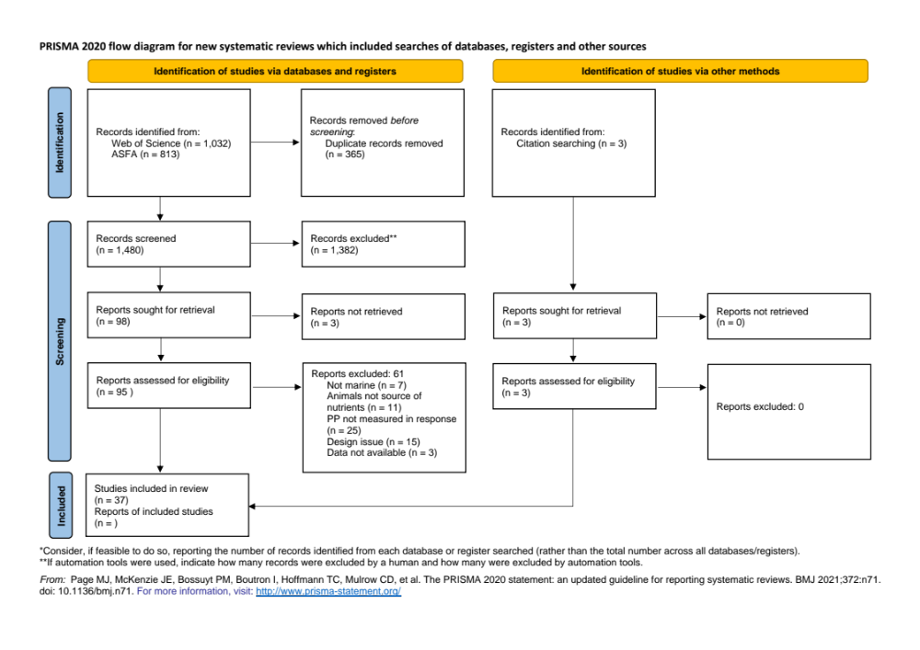
Figure S1: PRISMA diagram

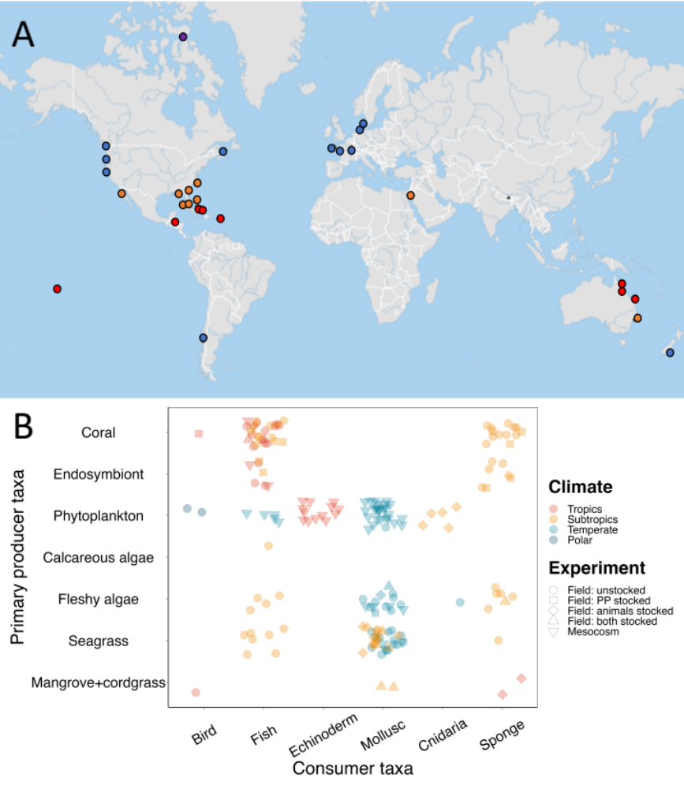
Figure 1. Description of studies included in the meta-analysis of effects of consumer-mediated nutrient cycling on marine primary producers. A) Geographical locations of studies; B) Combinations of primary producer groups, consumer groups, climate regions and experimental types.

Table S3. Complete list of primary producers included in this meta-analysis. For rows with NA for family, genus and species, the producer was considered at the community level and could not be captured by a single family or genus.
Group | Family | Genus | Species | n
Algae | Anadyomenaceae | Microdictyon | marinum | 1
Algae | Bangiaceae | Porphyra | perforata | 4
Algae | Dictyotaceae | Dictyota | spp. | 1
Algae | Ectocarpaceae | Ectocarpus | siliculosus | 6
Algae | Endocladiaceae | Endocladia | muricata | 1
Algae | Fucaceae | Pelvetiopsis | limitata | 1
Algae | Halymeniaceae | Prionitis | lanceolata | 1
Algae | Laminariaceae | Macrocystis | pyrifera | 1
Algae | Phyllophoraceae | Mastocarpus | papillatus | 1
Algae | Rhodomelaceae | Odonthalia | floccosa | 1
Algae | NA | NA | NA | 9
Coral | Acroporidae | Acropora | cervicornis | 1
Coral | Acroporidae | Acropora | formosa | 1
Coral | Acroporidae | Acropora | palmata | 2
Coral | Acroporidae | Porites | furcata | 2
Coral | Actiniidae | Entacmaea | quadricolor | 1
Coral | Pocilloporidae | Pocillopora | damicornis | 3
Coral | Pocilloporidae | Pocillopora | damicornus | 6
Coral | Pocilloporidae | Pocillopora | eydouxi | 2
Coral | Poritidae | Porites | furcata | 7
Coral | Poritidae | Porites | porites | 1
Coral | Siderastreidae | Siderastrea | radians | 8
Coral | Symbiodiniaceae | Symbiodinium | spp. | 4
Coral | NA | NA | NA | 17
Phytoplankton | Bacillariaceae | Nitzschia | acicularis | 2
Phytoplankton | Bacillariaceae | Nitzschia | closterium | 2
Phytoplankton | Bacillariaceae | Nitzschia | gandersheimiensis | 2
Phytoplankton | Brachidiniaceae | Karenia | mikimotoi | 2
Phytoplankton | Catenulaceae | Amphora | sp | 2
Phytoplankton | Chaetocerotaceae | Chaetoceros | gracilis | 2
Phytoplankton | Chaetocerotaceae | Chaetoceros | sp | 2
Phytoplankton | Chattonellaceae | Heterosigma | akashiwo | 3
Phytoplankton | Chlorodendraceae | Tetraselmis | suecica | 2
Phytoplankton | Entomoneidaceae | Entomoneis | alata | 2
Phytoplankton | Naviculaceae | Haslea | ostrearia | 2
Phytoplankton | Ostreopsidaceae | Alexandrium | catenella | 2
Phytoplankton | Ostreopsidaceae | Alexandrium | minutum | 2
Phytoplankton | Skeletonemataceae | Skeletonema | costatum | 2
Phytoplankton | NA | NA | NA | 24
Plants | Hydrocharitaceae | Thalassia | testudinum | 15
Plants | Poaceae | Spartina | alterniflora | 2
Plants | Rhizophoraceae | Rhizophora | mangle | 3
Plants | Zosteraceae | Zostera | marina | 23
Plants | NA | NA | NA | 2

Table S4. Metrics of primary producer performance reported in studies included in the meta-analysis, and associated descriptions and/or examples. 78 measured growth rate and 102 didn’t standardize to a unit of time. n = number of effect sizes included for each metric
Metric | n | Description/examples
density | 55 | Density of phytoplankton, seagrass shoots, and coral skeletal density
percent cover | 22 | Percent cover of algae and coral
biomass | 21 | Biomass of aboveground and belowground plant matter, algae, phytoplankton, seagrass, coral tissue, and carbon
photosynthesis | 20 | Production of oxygen by phytoplankton and seagrass
length | 12 | Length of seagrass leaves and shoots, and coral branches/nubbins
buoyant weight | 9 | Buoyant weight of corals
dry weight | 9 | Dry weight of seagrass shoots and coral tissue
Chl a | 8 | Concentration of chlorophyll A in water, tissue, and algae.
area | 7 | Area of algae thallus, anemone basal disk, coral surface, seagrass leaves and shoot coverage, and clonal outgrowth of cordgrass.
circumference | 6 | Coral circumference
count | 6 | Seagrass leaf/shoot count and kelp blade production.
protein | 3 | Tissue protein in corals
volume | 1 | Coral volume
width | 1 | Seagrass leaf width

Table S5: Species of animals used to provide nutrients in studies included in the meta-analysis. For rows with NA for family, genus and species the producer was considered at the community level and could not be captured by a single family or genus. n = number of effect sizes included for each animal species.
Group | Family | Genus | Species | n
Bird | NA | NA | NA | 4
Fish | Haemulidae | Haemulon | spp. | 11
Fish | Haemulidae | NA | NA | 7
Fish | Moronidae | Dicentrarchus | labrax | 3
Fish | Pomacentridae | Amphiprion | bicinctus | 1
Fish | Pomacentridae | Dascyllus | aruanus | 13
Fish | Pomacentridae | NA | NA | 1
Fish | Salmonidae | Salmo | salar | 2
Fish | NA | NA | NA | 13
Echinoderm | Holothuriidae | Holothuria | atra | 1
Echinoderm | NA | NA | NA | 12
Mollusc | Calyptraeidae | Crepidula | fornicata | 1
Mollusc | Mytilidae | Geukensia | demissa | 2
Mollusc | Mytilidae | Modiolus | americanus | 7
Mollusc | Mytilidae | Mytilus | californianus | 11
Mollusc | Mytilidae | Mytilus | chilensis | 2
Mollusc | Mytilidae | Mytilus | edulis | 24
Mollusc | Ostreidae | Magallana | gigas | 27
Mollusc | Veneridae | Mercenaria | mercenaria | 3
Cnidaria | Campanulariidae | Obelia | geniculata | 1
Cnidaria | Catostylidae | Catostylus | mosaicus | 5
Sponge | Aplysinidae | Aplysina | cauliformis | 1
Sponge | Chalinidae | Haliclona | implexiformis | 1
Sponge | Halichondriidae | Halichondria | melanadocia | 1
Sponge | Tedaniidae | Tedania | ignis | 1
Sponge | NA | NA | NA | 25

Primary producer performance
When we compared each of the models containing experimental design, primary producer taxa, and one of the correlated variables, i.e. absolute latitude, temperature, or background nutrients, against a null model, the model containing background nutrients had strongest support (Table 1). There was, however, some support for all three models with a correlated variable (1 < Δ𝑖 < 3), and little support for the null model (Δ𝑖 > 6, Table 1). Therefore, we report results from all three models.

Table 1. Comparison of models of marine primary producer performance in relation to background nutrient (or temperature or absolute latitude), experimental design (ED), and primary producer group (PPG). RE = random effect. K is the number of parameters included in the model, AIC is the Akaike’s Information Criterion for each model, ΔAIC is the AIC for each model minus the AIC from the best model, and AIC weight is the calculated weight of each model.
Moderators | K | AIC | ΔAIC | AIC weight
Background nutrients, ED, PPG, RE | 11 | 374.18 | 0 | 0.54
Temperature, ED, PPG, RE | 11 | 375.74 | 1.56 | 0.25
Absolute latitude, ED, PPG, RE | 11 | 376.20 | 2.01 | 0.20
RE | 3 | 380.78 | 6.59 | 0.02

Background nutrients model
Overall, we found a positive effect of animal-provisioned nutrients on primary productivity (log-transformed response ratio ± SE: 0.45± 0.16, p = 0.007), with producers growing nearly 3 times more, on average, under provisioned than control conditions. This estimate represents the effect of animal-provisioning at a mean level of background nutrients on algae (baseline primary producer group) in unstocked field experiments (baseline experimental design). There was a slightly positive but non-significant effect of background nutrients on the response of primary producers to animal-provisioned nutrients (0.11 ± 0.07, p = 0.16; Fig. 3, Table S6). The test of moderators was not statistically significant (F_{8,171} = 1.42, p = 0.19), and there was still a significant amount of unexplained residual heterogeneity (QE₁₇₁ = 3025.31, p < 0.001). The response ratio of all experimental designs, except field experiments with stocked producers, was consistently positive (no overlap of 95% CI with zero, Fig 3). The response of primary producers in unstocked field experiments (0.45 ± 0.16; provisioned producers grew 280% more than controls) was on average not significantly different than those in field experiments with stocked producers (0.32 ± 0.22; 208%), stocked consumers (0.82 ± 0.22; 664%) or mesocosms (0.58 ± 0.20; 376%). However, there was a larger effect of provisioning on primary productivity in field experiments where both consumers and producers were stocked (1.11 ± 0.32, 1274%; Fig. 3). Among primary producers, algae responded significantly positively to provisioning (no overlap of 95% CI with zero), but coral, phytoplankton, and plants did not respond significantly (Fig 3). Algae (0.45 ± 0.16; 280% increase) and corals (0.37 ± 0.21; 234%) showed the largest responses, on average, to animal-provisioned nutrients. Phytoplankton (0.09 ± 0.23; 123%) and vascular plants (0.11 ± 0.19; 129%) showed significantly smaller and more uncertain responses to provisioning.

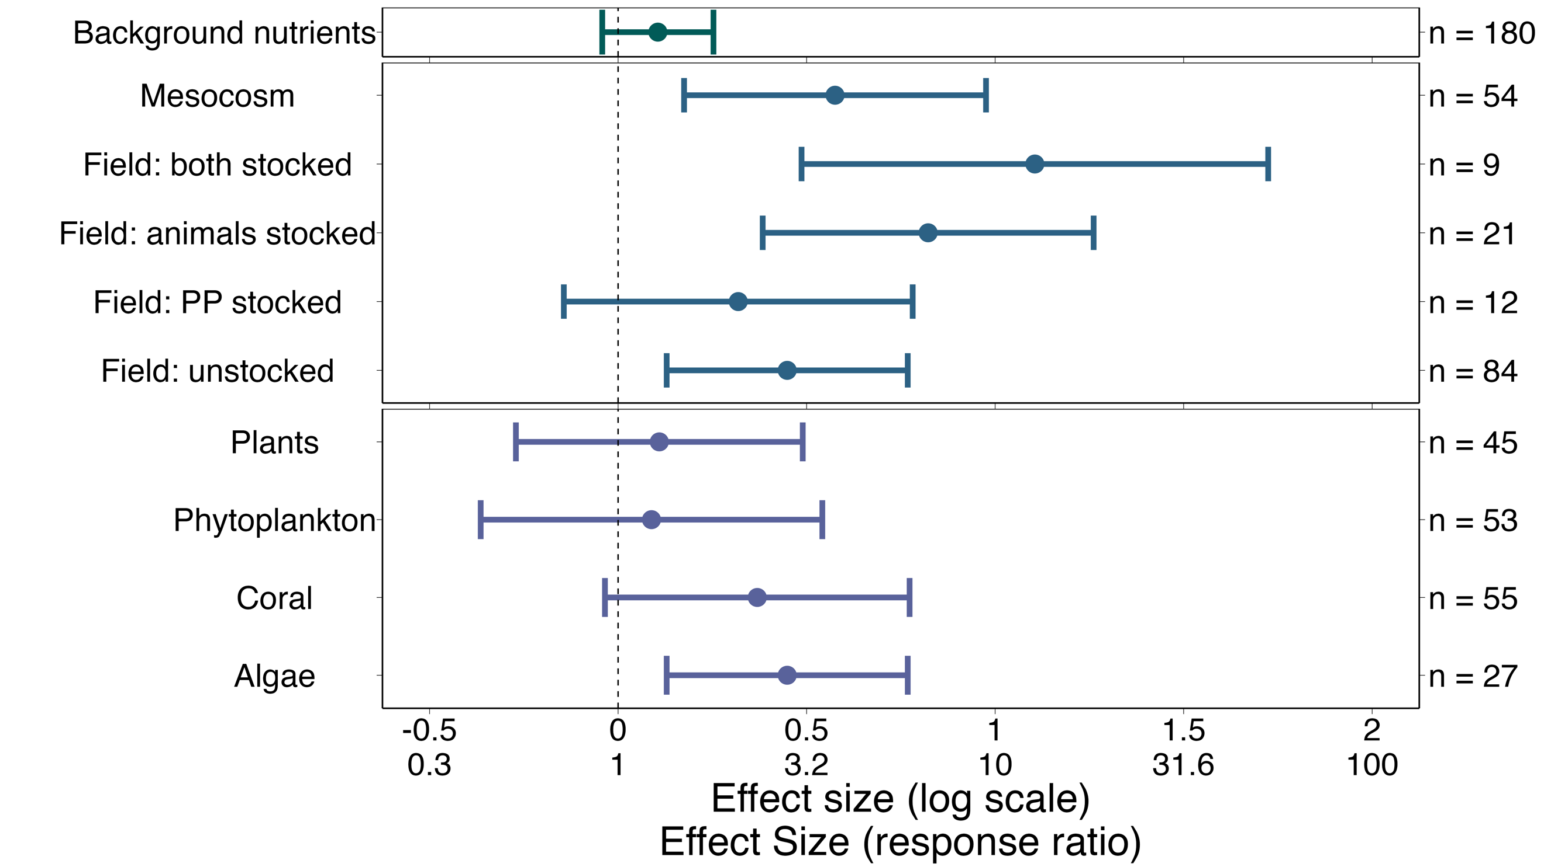
Fig. 3. Effect of background nutrients (top box), experimental design (middle box), and primary producer group (bottom box) on primary producers. Effect sizes shown in log-transformed ratios of means (top row of X axis) and as back-transformed ratios of means (bottom row of X axis). An effect size of 0 on the log scale or 1 on the ratio scale means that the primary producer grew the same with and without nutrient addition. Effect sizes to the right of the dotted line indicate positive responses to provisioning, and effect sizes to the left indicate negative responses. Experimental design included studies that manipulated the density of the primary producer (PP stocked), consumer (animals stocked), both, or neither (unstocked). See Methods for description of the primary producers groups. Effect sizes (filled dots) are surrounded by 95% confidence intervals derived from a three-level mixed-effects model. Sample size for each moderator level is shown to the right of the effect sizes.

Table S6: Model output for background nutrients model
 | estimate | SE | t-value | df | p-value
Intercept | 0.45 | 0.16 | 2.75 | 171 | 0.0066
Nut_stand | 0.11 | 0.075 | 1.41 | 171 | 0.16
Natural2 | -0.13 | 0.24 | -0.55 | 171 | 0.58
Natural3 | 0.37 | 0.22 | 1.67 | 171 | 0.09
Natural4 | 0.66 | 0.32 | 2.081 | 171 | 0.039
Natural5 | 0.13 | 0.20 | 0.62 | 171 | 0.54
pp_groupCoral | - 0.079 | 0.21 | -0.39 | 171 | 0.70
pp_groupPhytoplankton | - 0.36 | 0.23 | -1.56 | 171 | 0.12
pp_groupPlants | -0.34 | 0.19 | -1.75 | 171 | 0.082

Latitude and temperature models
We also found an overall positive effect of nutrient provisioning by animals in the model that included absolute latitude (0.51 ± 0.16, p = 0.0015). However, there was no evidence that the effect of nutrient provisioning varies with absolute latitude (-0.01 ± 0.08, p = 0.77; Fig. S3, Table S7). There was no evidence of differences between subgroups (F_{8, 171} = 1.19, p = 0.31), and a significant amount of unexplained residual heterogeneity remained (QE₁₇₁ = 2971.59, p < 0.001).
The model that included temperature also showed an overall positive effect of animal-provisioned nutrients overall (0.49 ± 0.16, p = 0.0024), but we found no evidence that the effect of provisioned nutrients varies with temperature (- 0.05 ± 0.07, p = 0.48; Fig. S4, Table S8). The test for moderators was not significant (F_{8,171} = 1.26, p = 0.27), and there was still a significant amount of unexplained residual heterogeneity (QE₁₇₁ = 3013.21, p < 0.001).
For both of these models, the differences between levels of the categorical moderators (i.e., experimental design and primary producer taxa) were roughly the same in magnitude and significance as in the model that included background nutrients (Tables S6, S8, S9, Fig S7, S8).
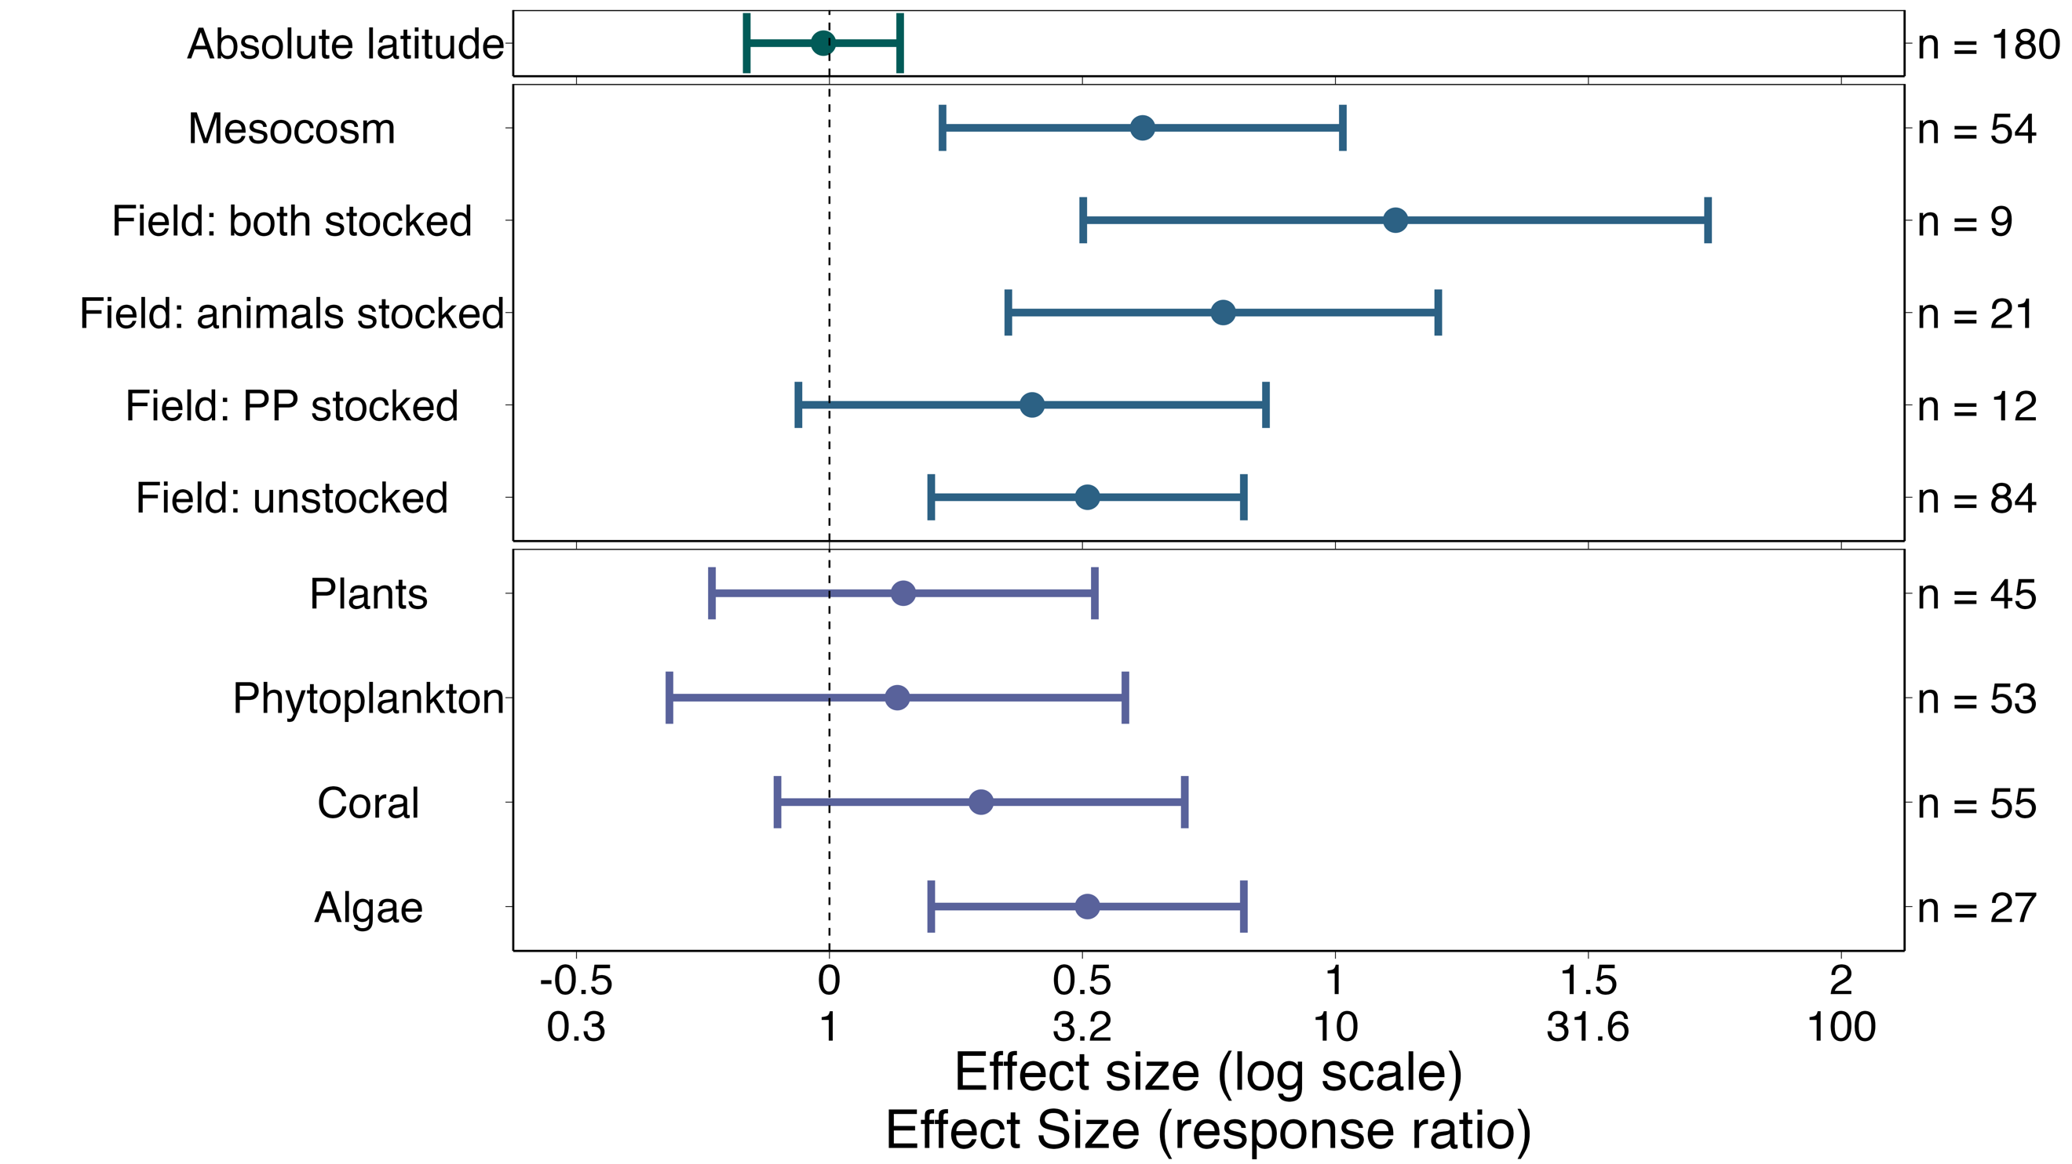
Figure S3. Effect sizes from absolute latitude model

Table S7: Model output for latitude model
 | estimate | SE | t-value | df | p-value
Intercept | 0.51 | 0.16 | 3.24 | 171 | 0.0015
Lat_stand | -0.012 | 0.077 | -0.15 | 171 | 0.88
Natural2 | -0.11 | 0.24 | -0.46 | 171 | 0.64
Natural3 | 0.27 | 0.22 | 1.24 | 171 | 0.22
Natural4 | 0.61 | 0.32 | 1.93 | 171 | 0.055
Natural5 | 0.11 | 0.21 | 0.54 | 171 | 0.59
pp_groupCoral | -0.21 | 0.21 | -1.024 | 171 | 0.31
pp_groupPhytoplankton | -0.38 | 0.23 | - 1.63 | 171 | 0.10
pp_groupPlants | -0.36 | 0.19 | -1.89 | 171 | 0.061

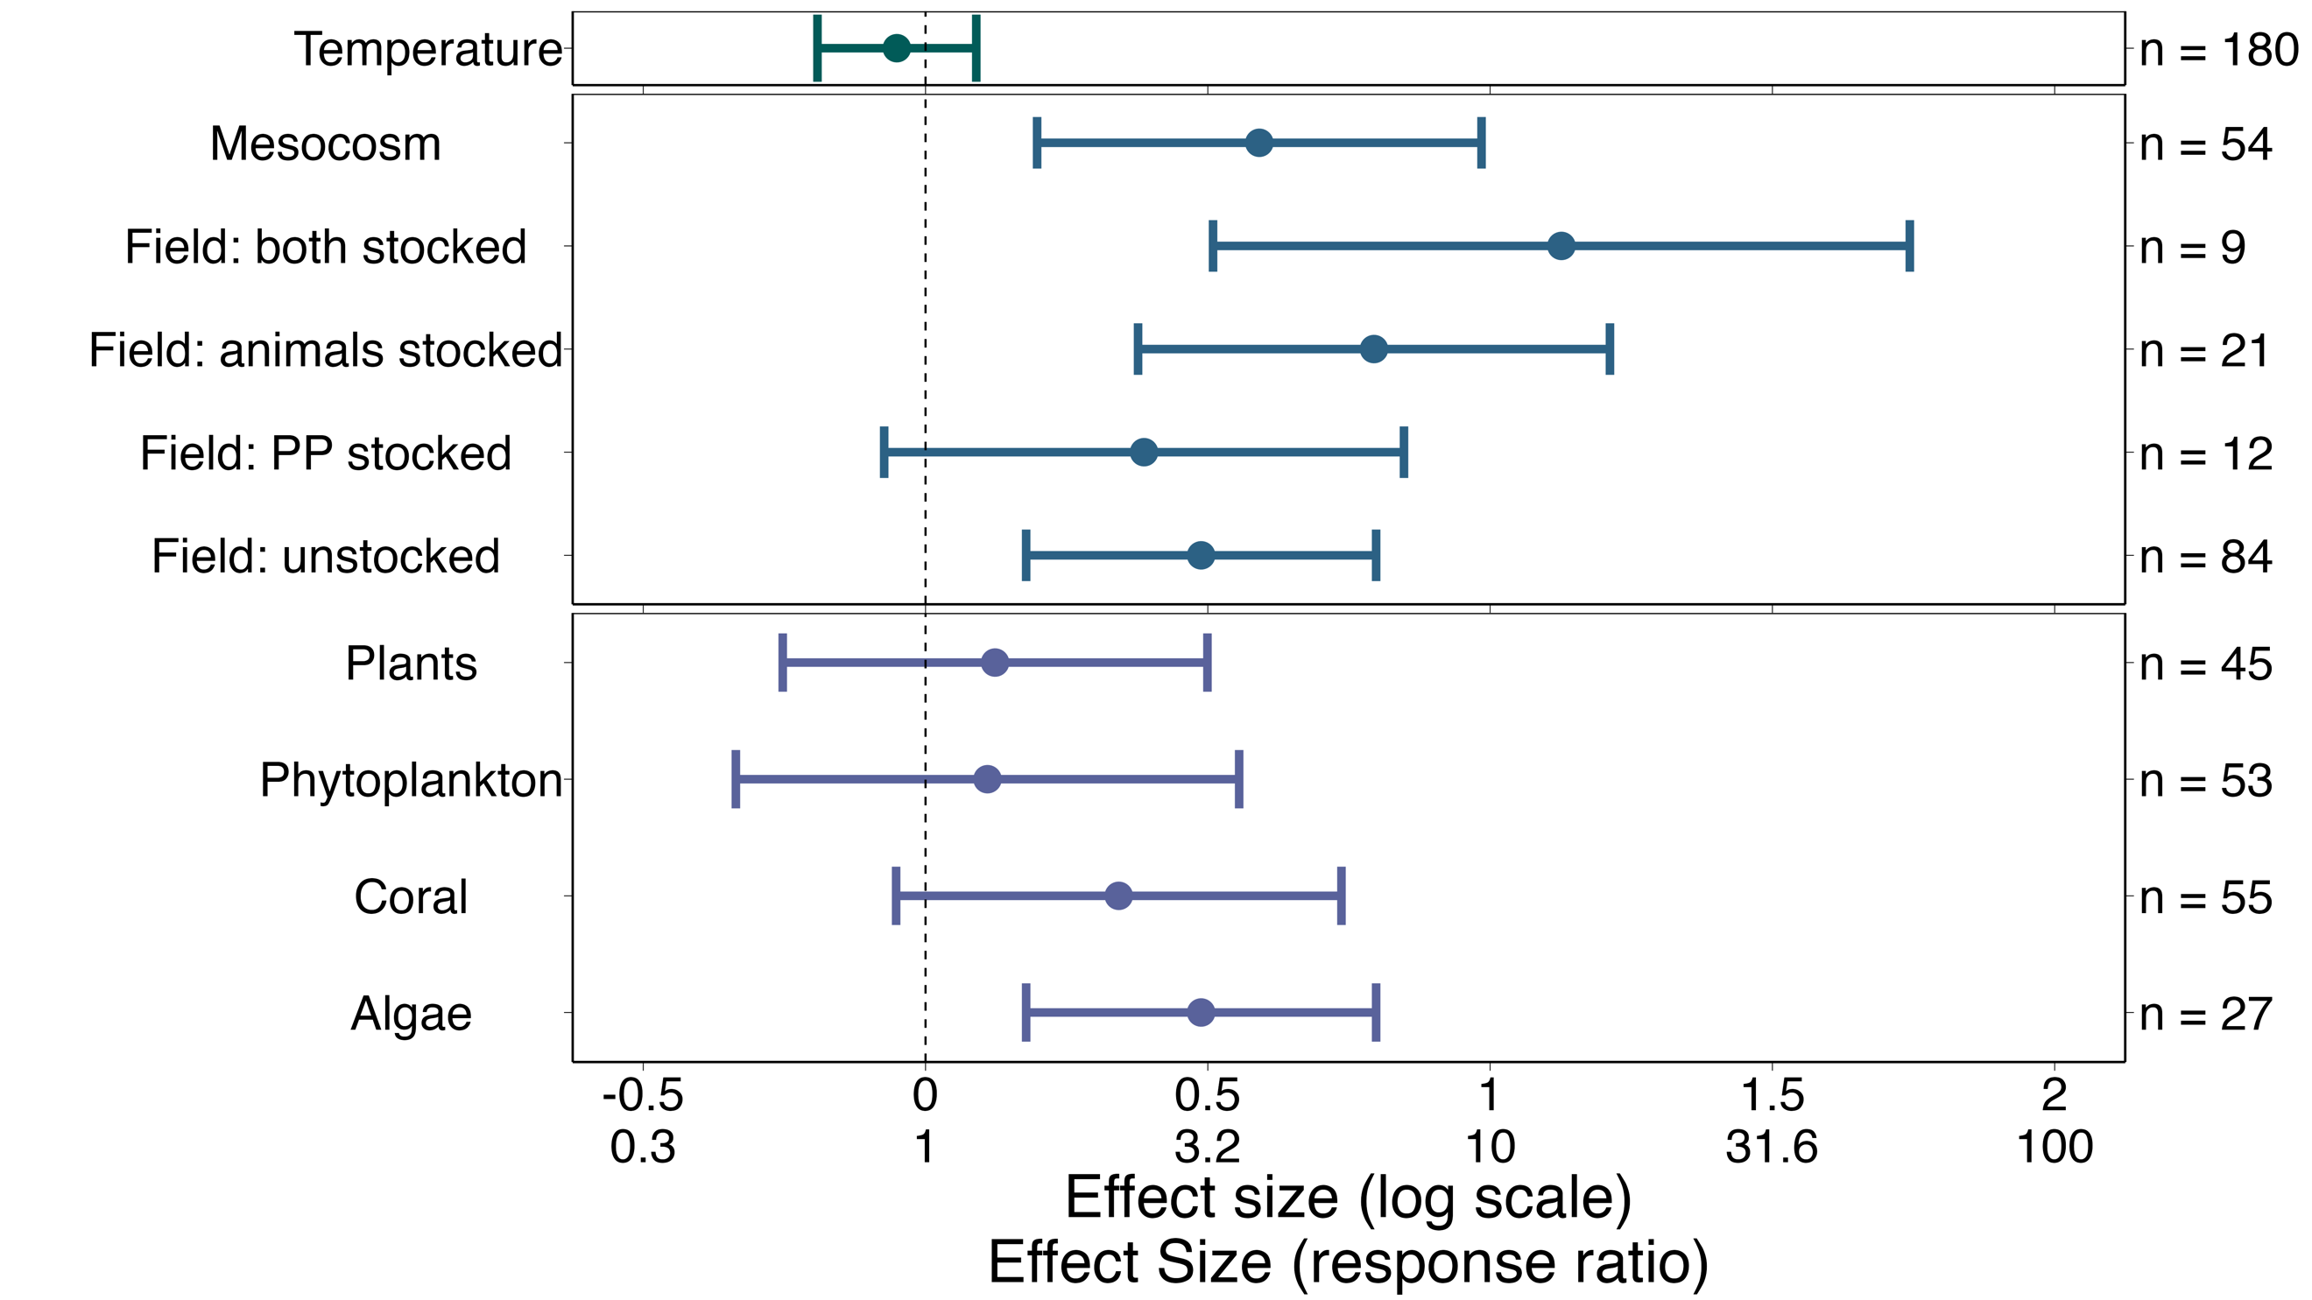
Figure S4: Effect sizes from temperature model

Table S8. Model output for temperature model
 | estimate | SE | t-value | df | p-value
Intercept | 0.49 | 0.16 | 3.09 | 171 | 0.0024
temp_stand | -0.051 | 0.071 | -0.72 | 171 | 0.48
Natural2 | -0.10 | 0.23 | -0.43 | 171 | 0.67
Natural3 | 0.31 | 0.21 | 1.44 | 171 | 0.15
Natural4 | 0.64 | 0.31 | 2.027 | 171 | 0.044
Natural5 | 0.10 | 0.20 | 0.51 | 171 | 0.61
pp_groupCoral | -0.15 | 0.20 | -0.72 | 171 | 0.47
pp_groupPhytoplankton | -0.38 | 0.23 | -1.66 | 171 | 0.098
pp_groupPlants | -0.36 | 0.19 | -1.90 | 171 | 0.059

Discussion
Overall, we found a consistently positive effect of animal-provisioned nutrients on the growth and performance of primary producers across studies, amounting to a 3 x increase(?. Consumers are therefore generally able to bolster primary productivity through nutrient addition, thus supporting their role in bottom-up processes. However, we did not find support for the idea that consumer-mediated nutrient cycling (CNC) has a larger effect on productivity in tropical, oligotrophic waters. There was no relationship between absolute latitude and the effect of CNC on productivity, suggesting the effect does not vary systematically between tropical and temperate waters. Two additional factors, background nutrient availability and temperature, that might influence more directly the assumed greater growth benefit to producers in the tropics also had no effect. We found that algae respond most strongly to nutrient provisioning, and that experimental design did not usually alter effect size (although field experiments with stocked producers showed weaker and less consistent responses to provisioning than other types of experiments). Large amounts of heterogeneity remained unexplained by our models, suggesting the effects of processes unaccounted for or high levels of natural variability. Taken together, these results suggest that the effect of CNC on primary productivity is driven by smaller-scale processes than the overall latitude or tropicalization of regions.

This paragraph: The hypothesis under test (latitude) (Fig S3)
Not only did we find no significant effect of absolute latitude on the effect of CNC on productivity, but our estimate for the slope of this relationship was slightly negative. This is contrary to the conventional wisdom, which suggest that CNC should have the greatest effect at low, nutrient-poor latitudes (Allgeier et al., 2017; Atkinson et al., 2017). However, we are not the first to find a similar effect of fertilization between tropical and temperate regions. (Gruner et al., 2008) found similar impacts of fertilization on productivity between temperate rocky reefs and coral reefs. –need more here--

This paragraph: background nutrients (Fig 3)
One reason underpinning the assumption that CNC is most important in the tropics is the low external nutrient input into low-latitude ecosystems. In tropical waters, external nutrients from run-off, atmospheric fixation, and upwelling provide less than X% of ?? (CITE). Conversely, some temperate regions receive massive amounts of nitrogen from upwelling and run-off (Pawlowicz, 2017). However, if the correlation between the availability of background nutrients and latitude is weak, the former could be more important than the latter. Our results suggest that there is high variability of background nutrients at high latitudes so there are high-latitude places that are as nutrient-impoverished as tropical areas. Nevertheless, we found no significant effect of background nutrient concentrations on the effect of CNC on productivity. Moreover, the average effect of background nutrients was positive, suggesting that producers may respond more strongly to CNC in more nutrient-rich waters. While this is at odds with the conventional wisdom that CNC should have a greater effect in nutrient-poor environments, this may be in line with plant physiology. Past exposure to nutrients can influence future uptake rates, and some plants grown in high-nitrogen conditions have a greater ability to uptake ammonium (Zalamea et al., 2016). In fertilization experiments, plots are sometimes taken over by producers with larger potential for uptake and assimilation of these nutrients (Gough et al., 2016), so it follows that producer communities exposed to high nutrient availability may be composed of species that are able to uptake and use nutrients well. For example, temperate seaweeds, such as giant kelp Latin name, from nutrient-rich waters have a high surge uptake capacity, being able to quickly take up and store large amounts of nitrogen (Cedeno et al., 2021). Therefore, it is physiologically possible that CNC could actually produce stronger effects on producers in nutrient-replete waters, although the high variability in our data… .

However, temperate regions also experience nutrient limitation, due to reduced flow (ie tidepools, (Bracken, 2004) or periods of inactivity with regards to upwelling (McPhee-Shaw et al., 2007). Under these conditions of nutrient limitation, we see producers respond strongly to the effect of CNC (Bracken et al., 2007). Interestingly, in the same region researchers sought to quantify the effect of CNC on productivity even when both flow and nutrient availability is high, and still found strong effects of nutrient provisioning (Aquilino et al., 2009). Therefore, if we assume the effect of CNC is high in the tropics because of low nutrients, we shouldn’t be surprised to see large effects of CNC in temperate areas which also undergo nutrient limitation. Further, even when nitrate-replete, high flow conditions, we still see large effects of CNC. Therefore, perhaps it is not the level of external nutrient input that determines the effect of CNC on producers.

The ability of consumers to significantly fertilize producers with their excretions, even in nitrate-replete water, is likely due to the increased fertilization capabilities of ammonium relative to nitrate. Many consumers excrete ammonium as metabolic waste, and their egestion can enrich the organic nitrogen content of sediment, which microbes then remineralize as ammonium. Ammonium is a positively charged ion, which can be absorbed through passive or facilitated uptake, and active uptake (Lobban and Harrison, 1994). Conversely, nitrate, which is negatively charged, must move across the electrochemical potential gradient, and thus requires active transport. This is supported by uptake studies that find ammonium update generally increases linearly with increasing concentrations, while the uptake of nitrate saturates (Phillips and Hurd, 2004). Further, once nitrate is inside the cell, it requires conversion to ammonium before it can be assimilated as amino acids. Therefore, increases in ammonium may bolster productivity even in the presence of abundant nitrate, as ammonium is less energetically costly to uptake and assimilate than nitrate.

You need one or two short paragraphs here to address the results of the temp model, experimental and taxonomic differences/similarity, which will wrap up the direct discussion of the results, allowing you to move on to more general discussion points.

Although we found that CNC did not have a larger effect in tropical than in temperate marine ecosystems, our meta-analysis was unsuited to answer whether or not it is more important in the tropics. Vitousek et al. (2010) distinguishes between limiting nutrients, which can increase growth, and ultimate nutrients, which can transform entire environments. In the Arctic, for example, the addition of nitrogen and phosphorus not only increases net primary production but also alters food webs, geophysical processes, and more, making these two elements ultimate nutrients in that environment (Gough et al., 2016). Nitrogen may similarly be an ultimate nutrient in oligotrophic marine ecosystems. The excretions of coral reef fishes onto new artificial reefs start positive feedback loops, which can create novel ecosystems where seascapes were otherwise bare (Layman et al., 2016). Fish pee may be an ecosystem stabilizer; it once supported the growth of corals, but now fertilizes an alternate stable state: fleshy algae (Allgeier et al., 2017). In contrast, nitrogen/CNC does not appear to transform temperate marine ecosystems as dramatically. CNC may increase diversity of producer communities (Bracken and Stachowicz, 2006) and may help to support kelp growth once spring upwelling ceases, but it is often thought of and considered as a supplement to upwelling, not as the primary source of nutrients (Brzezinksi et al., 2013). Therefore, CNC may be a more important process in the tropics, even though it does not produce larger effects than in temperate ecosystems.

We were surprised to discover how few studies (X/X) provided data on the environmental conditions under which experiments were run. We initially attempted to quantify the level of provisioning provided by consumers, but these data were often not available. More surprising was the absence of information on ambient nutrient availability. We suggest that future research on CNC report ambient nitrate and ammonium concentrations in uM or other standardized units to facilitate comparisons across studies. The lack of data required us to estimate both background nutrient levels and temperature for a number of studies, which might have introduced noise. However, given the magnitude of variance in these variables (X – X uM of nitrogen, X- X degrees in temperature), we are confident that our estimates distinguished fairly between low and high nitrogen sites. Our studies were strongly biased towards North American and European countries, which was likely a combined effect of the databases used in our literature search and the search and publication bias towards English-speaking countries. More data from the Global South would have improved our analyses.

In conclusion, we found a positive effect of consumer-mediated nutrient cycling on marine primary productivity, providing further evidence that CNC is an important contributor to bottom-up processes. However, we did not find evidence to support the conventional wisdom that CNC should have larger effects on marine producers in tropical regions when we examined the effects of absolute latitude, ambient nutrient availability, and temperature. Therefore, we suggest that the impact of CNC may not vary on such broad scales and is instead controlled by finer-scale variables, including …. Consumers in temperate, nutrient-replete waters may be more important for bottom-up processes than initially thought. As humans continue to reduce and redistribute animal biomass worldwide, alter nutrient cycles through eutrophication, and threaten oceanographic processes through climate change, it becomes increasingly important to understand the role of animals in supporting primary productivity.

SUPPLEMENT
Full search string
(ammon* OR nitrog* OR phosph* OR nutrient*) AND (excret* OR egest* OR mutual* OR symbio* OR subsid* OR consumer-mediat*) AND (coral* OR kelp* OR alga* OR macroalgae OR microalgae OR phytoplankton OR zooxanthell* OR primary prod* OR seagrass* OR sea grass* OR seaweed* OR mangrove*) AND (reef OR subtidal OR intertidal OR coast* OR marine OR benthic OR coral OR kelp) AND (grow* OR grew OR biomass OR abundance OR weight).

References
Allgeier, J.E., Burkepile, D.E., Layman, C.A., 2017. Animal pee in the sea: consumer-mediated nutrient dynamics in the world’s changing oceans. Global Change Biology 23, 2166–2178. https://doi.org/10.1111/gcb.13625
Allgeier, J.E., Rosemond, A.D., Layman, C.A., 2011. The frequency and magnitude of non-additive responses to multiple nutrient enrichment. Journal of Applied Ecology 48, 96–101. https://doi.org/10.1111/j.1365-2664.2010.01894.x
Aquilino, K.M., Bracken, M.E.S., Faubel, M.N., Stachowicz, J.J., 2009. Local-scale nutrient regeneration facilitates seaweed growth on wave-exposed rocky shores in an upwelling system. Limnology and Oceanography 54, 309–317. https://doi.org/10.4319/lo.2009.54.1.0309
Atkinson, C.L., Capps, K.A., Rugenski, A.T., Vanni, M.J., 2017. Consumer-driven nutrient dynamics in freshwater ecosystems: from individuals to ecosystems. Biological Reviews 92, 2003–2023. https://doi.org/10.1111/brv.12318
Bracken, M.E.S., 2004. Invertebrate-Mediated Nutrient Loading Increases Growth of an Intertidal Macroalga1. Journal of Phycology 40, 1032–1041. https://doi.org/10.1111/j.1529-8817.2004.03106.x
Bracken, M.E.S., Gonzalez-Dorantes, C.A., Stachowicz, J.J., 2007. Whole-community mutualism: Associated invertebrates facilitate a dominant habitat-forming seaweed. Ecology 88, 2211–2219. https://doi.org/10.1890/06-0881.1
Bracken, M.E.S., Stachowicz, J.J., 2006. Seaweed Diversity Enhances Nitrogen Uptake Via Complementary Use of Nitrate and Ammonium. Ecology 87, 2397–2403. https://doi.org/10.1890/0012-9658(2006)87[2397:SDENUV]2.0.CO;2
Brzezinksi, M., Reed, D., Harrer, S., Rassweiler, A., Melack, J., Goodridge, B., Dugan, J., 2013. Multiple sources and forms of nitrogen sustain year-round kelp growth on the inner continental shelf of the Santa Barbara Channel. oceanog 26, 114–123. https://doi.org/10.5670/oceanog.2013.53
Burnham, K.P., Anderson, D.R., Huyvaert, K.P., 2011. AIC model selection and multimodel inference in behavioral ecology: some background, observations, and comparisons. Behav Ecol Sociobiol 65, 23–35. https://doi.org/10.1007/s00265-010-1029-6
Cedeno, T.H., Brzezinski, M.A., Miller, R.J., Reed, D.C., 2021. An evaluation of surge uptake capability in the giant kelp (Macrocystis pyrifera) in response to pulses of three different forms of nitrogen. Mar Biol 168, 166. https://doi.org/10.1007/s00227-021-03975-z
Elser, J.J., Bracken, M.E.S., Cleland, E.E., Gruner, D.S., Harpole, W.S., Hillebrand, H., Ngai, J.T., Seabloom, E.W., Shurin, J.B., Smith, J.E., 2007. Global analysis of nitrogen and phosphorus limitation of primary producers in freshwater, marine and terrestrial ecosystems. Ecology Letters 10, 1135–1142. https://doi.org/10.1111/j.1461-0248.2007.01113.x
Elser, J.J., Urabe, J., 1999. The Stoichiometry of Consumer-Driven Nutrient Recycling: Theory, Observations, and Consequences. Ecology 80, 735–751. https://doi.org/10.1890/0012-9658(1999)080[0735:TSOCDN]2.0.CO;2
Fortier, R., Wright, S.J., 2021. Nutrient limitation of plant reproduction in a tropical moist forest. Ecology 102, e03469. https://doi.org/10.1002/ecy.3469
Gough, L., Bettez, N.D., Slavik, K.A., Bowden, W.B., Giblin, A.E., Kling, G.W., Laundre, J.A., Shaver, G.R., 2016. Effects of long-term nutrient additions on Arctic tundra, stream, and lake ecosystems: beyond NPP. Oecologia 182, 653–665. https://doi.org/10.1007/s00442-016-3716-0
Gruner, D.S., Smith, J.E., Seabloom, E.W., Sandin, S.A., Ngai, J.T., Hillebrand, H., Harpole, W.S., Elser, J.J., Cleland, E.E., Bracken, M.E.S., Borer, E.T., Bolker, B.M., 2008. A cross-system synthesis of consumer and nutrient resource control on producer biomass. Ecology Letters 11, 740–755. https://doi.org/10.1111/j.1461-0248.2008.01192.x
Hillman, K., Walker, D.I., Larkum, A.W.D., McComb, A.J., 1989. Productivity and nutrient limitation, in: Larkum, A.W.D., McComb, A.J., Shephard, S.A. (Eds.), Biology of Seagrasses : A Treatise on the Biology of Seagrasses with Special Reference to the Australian Region. Elsevier Science Pub., Amsterdam, The Netherlands, pp. 635–685.
Jackson, G.A., 1977. Nutrients and production of giant kelp, Macrocystis pyrifera, off southern California. Limnology and Oceanography 22, 979–995.
Layman, C.A., Allgeier, J.E., Montaña, C.G., 2016. Mechanistic evidence of enhanced production on artificial reefs: A case study in a Bahamian seagrass ecosystem. Ecological Engineering 95, 574–579. https://doi.org/10.1016/j.ecoleng.2016.06.109
Lobban, C.S., Harrison, P.J., 1994. Seaweed Ecology and Physiology. Cambridge University Press.
McNaughton, S.J., Ruess, R.W., Seagle, S.W., 1988. Large mammals and process dynamics in African ecosystems. BioScience 38, 794–800. https://doi.org/10.2307/1310789
McPhee-Shaw, E.E., Siegel, D.A., Washburn, L., Brzezinski, M.A., Jones, J.L., Leydecker, A., Melack, J., 2007. Mechanisms for nutrient delivery to the inner shelf: Observations from the Santa Barbara Channel. Limnology and Oceanography 52, 1748–1766. https://doi.org/10.4319/lo.2007.52.5.1748
Meyer, J.L., Schultz, E.T., Helfman, G.S., 1983. Fish schools: An asset to corals. Science 220, 1047–1049. https://doi.org/10.1126/science.220.4601.1047
Moore, C.M., Mills, M.M., Arrigo, K.R., Berman-Frank, I., Bopp, L., Boyd, P.W., Galbraith, E.D., Geider, R.J., Guieu, C., Jaccard, S.L., Jickells, T.D., La Roche, J., Lenton, T.M., Mahowald, N.M., Marañón, E., Marinov, I., Moore, J.K., Nakatsuka, T., Oschlies, A., Saito, M.A., Thingstad, T.F., Tsuda, A., Ulloa, O., 2013. Processes and patterns of oceanic nutrient limitation. Nature Geoscience 6, 701–710. https://doi.org/10.1038/ngeo1765
Pawlowicz, R., 2017. Seasonal cycles, hypoxia, and renewal in a coastal fjord (Barkley Sound, British Columbia). Atmosphere-Ocean 55, 264–283. https://doi.org/10.1080/07055900.2017.1374240
Peterson, B., Heck, K., 2001. Positive interactions between suspension-feeding bivalves and seagrass-a facultative mutualism. Mar. Ecol. Prog. Ser. 213, 143–155. https://doi.org/10.3354/meps213143
Pfister, C.A., Altabet, M.A., Post, D., 2014. Animal regeneration and microbial retention of nitrogen along coastal rocky shores. Ecology 95, 2803–2814. https://doi.org/10.1890/13-1825.1
Phillips, J.C., Hurd, C.L., 2004. Kinetics of nitrate, ammonium, and urea uptake by four intertidal seaweeds from New Zealand. Journal of Phycology 40, 534–545. https://doi.org/10.1111/j.1529-8817.2004.03157.x
Probyn, T.A., McQuaid, C.D., 1985. In-situ measurements of nitrogenous nutrient uptake by kelp (Ecklonia maxima) and phytoplankton in a nitrate-rich upwelling environment. Mar. Biol. 88, 149–154. https://doi.org/10.1007/BF00397162
Ryther, J.H., Dunstan, W.M., 1971. Nitrogen, phosphorus, and eutrophication in the coastal marine environment. Science 171, 1008–1013. https://doi.org/10.1126/science.171.3975.1008
Schindler, D.W., 1974. Eutrophication and Recovery in Experimental Lakes: Implications for Lake Management. Science 184, 897–899. https://doi.org/10.1126/science.184.4139.897
Sitters, J., Bakker, E.S., Veldhuis, M.P., Veen, G.F., Olde Venterink, H., Vanni, M.J., 2017. The stoichiometry of nutrient release by terrestrial herbivores and its ecosystem consequences. Front. Earth Sci. 5. https://doi.org/10.3389/feart.2017.00032
Smith, V.H., Tilman, G.D., Nekola, J.C., 1999. Eutrophication: impacts of excess nutrient inputs on freshwater, marine, and terrestrial ecosystems. Environmental Pollution 100, 179–196. https://doi.org/10.1016/S0269-7491(99)00091-3
Vanni, M.J., 2002. Nutrient cycling by animals in freshwater ecosystems. Annual Review of Ecology and Systematics 33, 341–370. https://doi.org/10.1146/annurev.ecolsys.33.010802.150519
Viechtbauer, W., 2010. Conducting Meta-Analyses in R with the metafor Package. J. Stat. Soft. 36. https://doi.org/10.18637/jss.v036.i03
Zalamea, P.-C., Turner, B.L., Winter, K., Jones, F.A., Sarmiento, C., Dalling, J.W., 2016. Seedling growth responses to phosphorus reflect adult distribution patterns of tropical trees. New Phytologist 212, 400–408. https://doi.org/10.1111/nph.14045

